Day 3 tasks:

Session 1:

Created resume portfolio using Bootstrap.

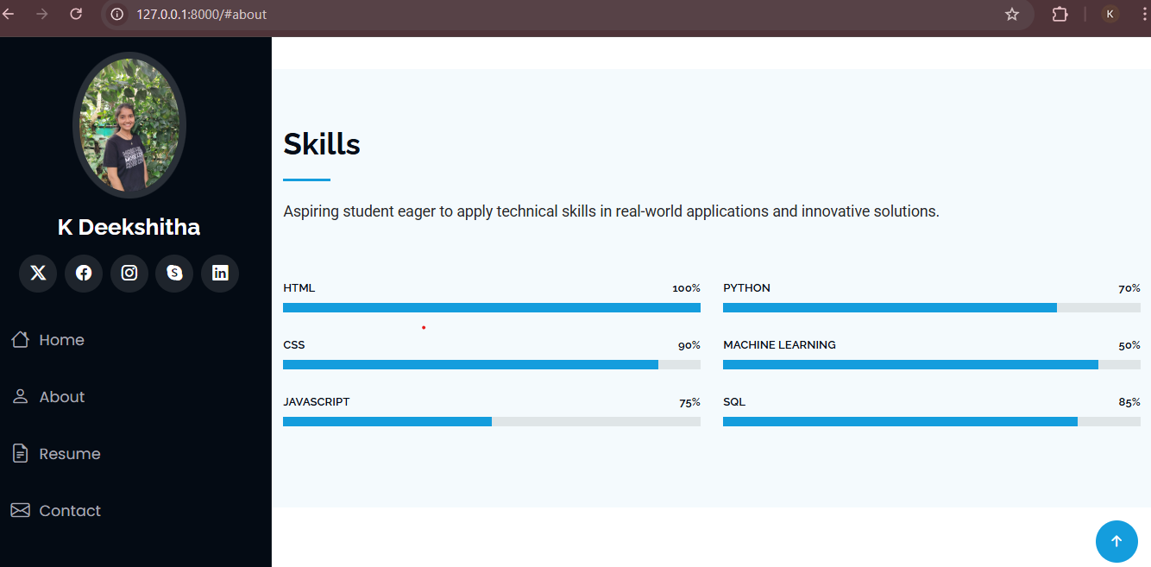

Session 2:

Wrote test cases for the given Weathershopper application on Testmo (a test case management tool).

